ContactManagement_Verify Contact notes _Instance44_12-Jul-2018_03-32-01_AM_MouseClickActiononStaleElement.png

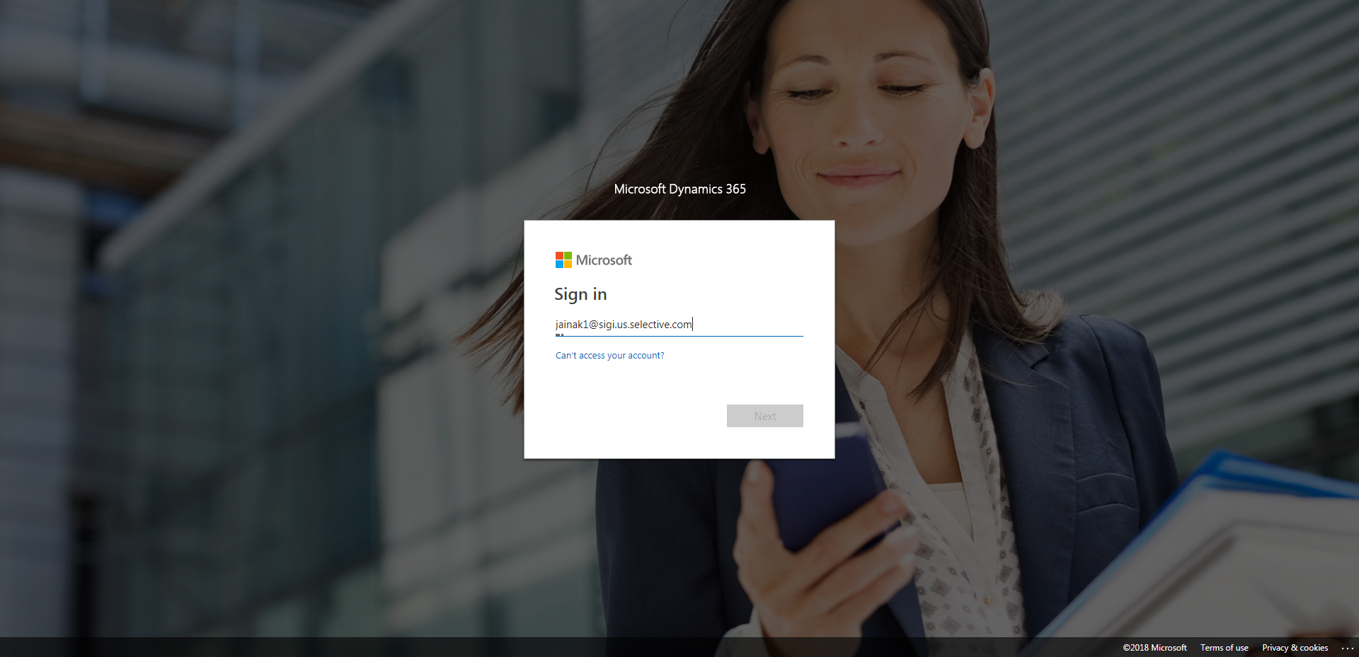

ContactManagement_Verify Contact notes _Instance44_12-Jul-2018_03-33-27_AM_VerifyingAllNotesofanindividual.png

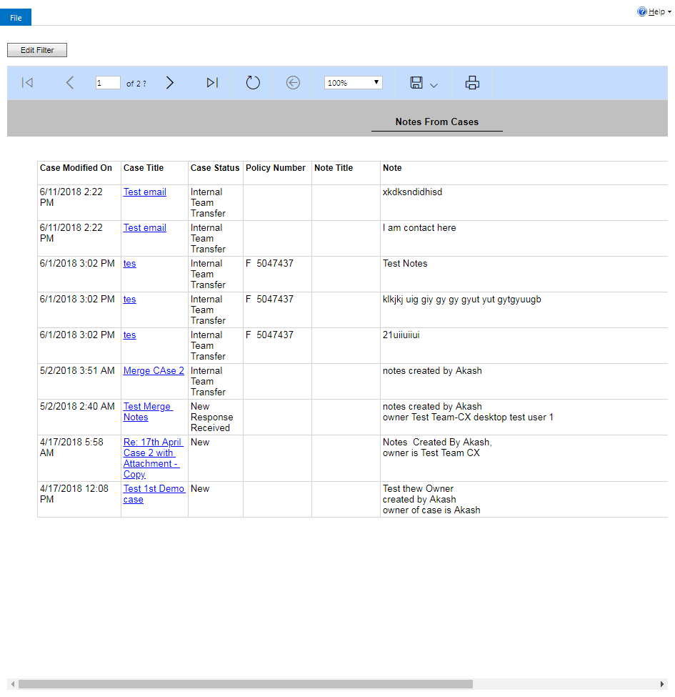

ContactManagement_Verify Contact notes _Instance44_12-Jul-2018_03-32-13_AM_SingleSignOn.png

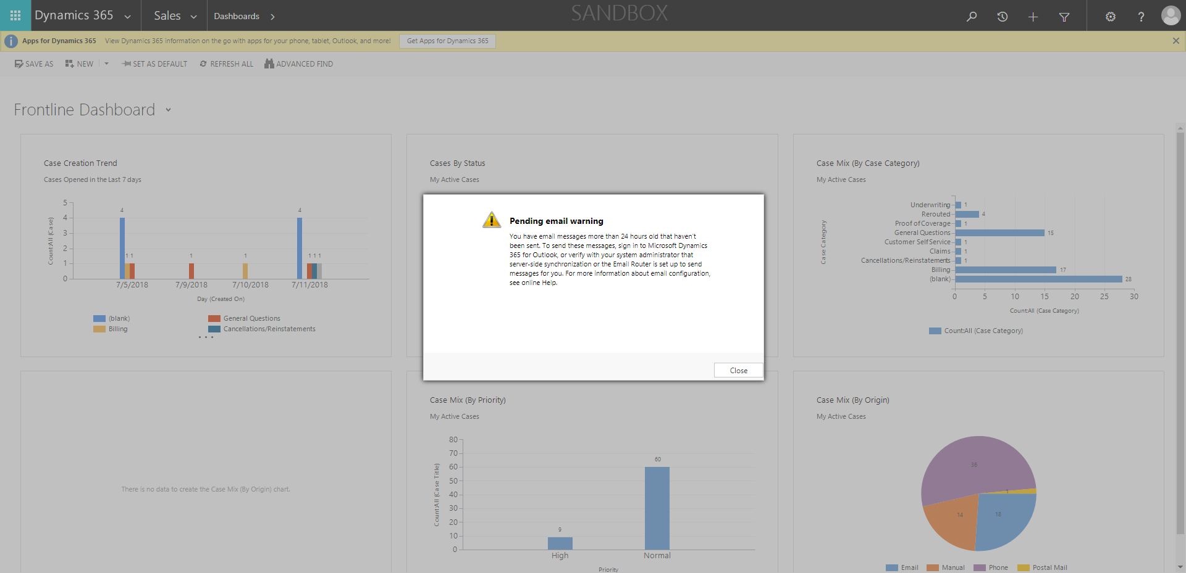

ContactManagement_Verify Contact notes _Instance44_12-Jul-2018_03-31-59_AM_MouseClickActiononStaleElement.png



ContactManagement_Verify Contact notes _Instance44_12-Jul-2018_03-32-00_AM_EnterTextAction.png



ContactManagement_Verify Contact notes _Instance44_12-Jul-2018_03-32-17_AM_SingleSignOn.png

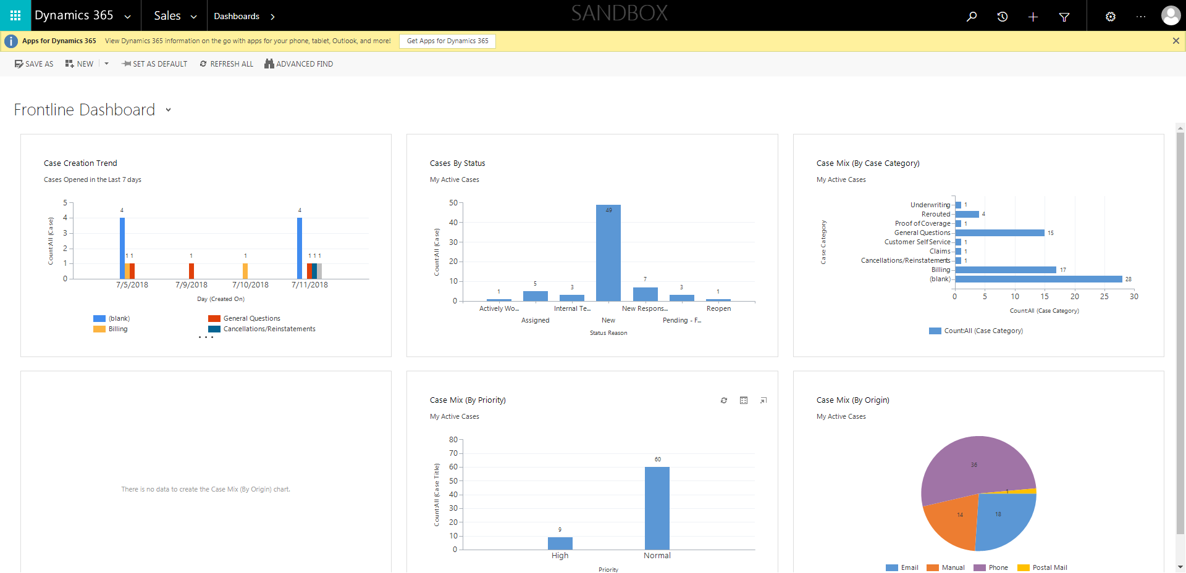

ContactManagement_Verify Contact notes _Instance44_12-Jul-2018_03-33-22_AM_Validatingcontactentitynavigation.png

